Mockito Hands-On Exercises
Exercise 1: Mocking and Stubbing

ExternalApi.java:
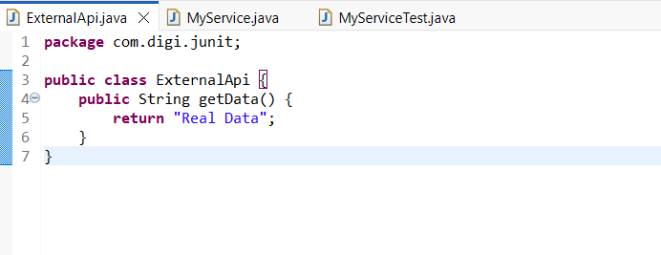
MyService.java:
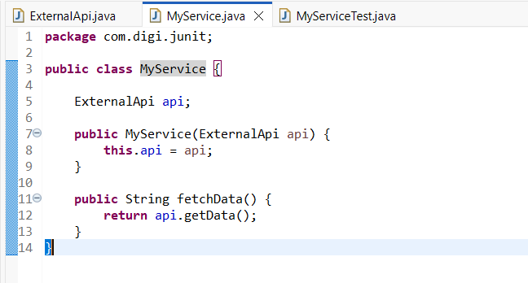

MyServiceTest.java:
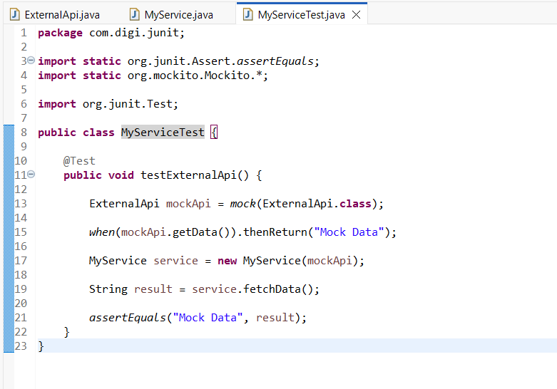

Output:
